Practical 1: Basic Image Handling

Bibek Manandhar

20070282

BE-CMP

EEC

30/01/2024

**Summary:**

The basic image handling using Java and the Eclipse IDE is the main topic of this practical. The code that is provided shows how to read, store, and display photos. Techniques for processing grayscale images are covered, with an emphasis on memory efficiency.

Keywords— BufferedImage, Grayscale Processing, Image Handling, ImageIO, Java, Java Swing.

I. PROBLEM DESCRIPTION

Java is used in this lab to process images and identify patterns. Java as a language was selected to balance ease of use and speed in development. Java is a good choice for software development and research since it has built-in classes for processing images. Four distinct challenges are given, ranging from using mean and median intensity values to explore various thresholding strategies to constructing binary images by thresholding. The practical also emphasizes how crucial flexible code development is.

II. THEORITICAL BACKGROUND

Handling colored and grayscale images requires image knowledge, which promotes the extraction of red, green, and blue components for better algorithm implementation. An M*N array of pixels with varying intensities combined to provide a visual representation is called an image.

BufferedImage.TYPE_BYTE_GRAY` is a specific format used to represent grayscale images in Java. In

this format:

- Each pixel in the image is represented using 8 bits (1 byte).

- The pixel values range from 0 to 255, where 0 represents black and 255 represents white.

III.RESULTS AND LESSONS LEARNT

The testing process comprised running the given code, extracting grayscale data into a 2D integer array, and using the designated processing algorithms to solve each problem. By utilizing mean and median intensity data to alter thresholding approaches, we were able to successfully construct binary images. The experiments showed that Java can handle images effectively, and the outcomes matched expectations.

PROGRAM LISTING

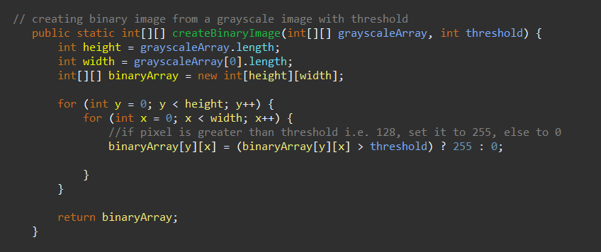I Greyscale image

Figure : Greyscale code

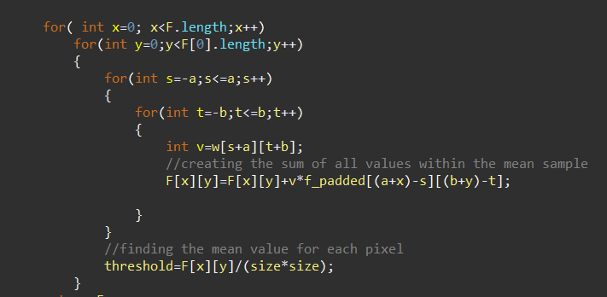II Using Mean Value as threshold

Figure : Using Mean value as threshold

This question uses the same code block as greyscale, but Mean is calculated from the

neighbouring pixels and used as the threshold value.

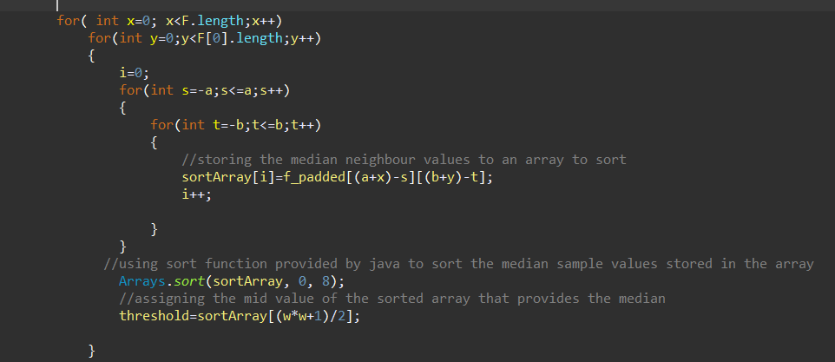III Using median value as threshold

Figure : Using Median Value as threshold

Similar to Mean Threshold code, Median is calculated by sorting the pixels and finding the

median and using it as the threshold